**UC Davis Hubble Reboost Mission Design**

***Customer Expectations/Mission Requirements – v1***

* Scientists had hoped to operate Hubble at the same time as the James Webb Space Telescope, currently planned for launch in late 2018. In spite of its giant 6.5-meter primary mirror, and its being advertised as a “successor” to Hubble, it is not a successor. Webb is optimized for infrared wavelengths extending just into the visible range (orange), while Hubble operates at ultraviolet and visible wavelengths, extending just into the near-infrared. The two instruments are complementary, with a slight overlap. There is no successor to Hubble; no comparably large space telescope designed to observe at visible or ultraviolet wavelengths is anywhere near launch.
* "The JWST project continues to report that it remains on schedule and budget with its overall schedule reserve currently above its plan," Chaplain said in [her testimony to Congress](https://science.house.gov/sites/republicans.science.house.gov/files/documents/HHRG-114-SY16-WState-CChaplain-20150324.pdf). "However, the project is now entering a difficult phase of development — integration and testing — which is expected to take another 3.5 years to complete.

"Maintaining as much schedule reserve as possible is critical during this phase to resolve known risks and unknown problems that may be discovered," Chaplain added. "Being one of the most complex projects in NASA’s history, significant risks lie ahead for the project, as it is during integration and testing where problems are likely to be found, and as a result, schedules tend to slip." <http://www.space.com/28921-james-webb-space-telescope-budget.html>

* Current Webb telescope launch date 10/2018
* Given the above statements (and experience with large spacecraft development), assume a 5-year JWST launch delay due to testing/redesign/budget difficulties, to new date 10/2023
* Reboost HST spacecraft to circular orbit so that useful operation until orbit decay is extended to 5 years beyond the JWST 10/23 launch date, i.e. to 10/28 (currently estimated HST end-of-life is 2020)
* Include effects of solar cycle on atmospheric drag
* asd.gsfc.nasa.gov/archive/hubble/a_pdf/news/facts/sm3b/fact_sheet_reboost.pdf
* Assume robotic reboost vehicle launch 1/20
* Reboost vehicle must:
  + Launch on an existing US launcher from Cape Canaveral into the HST orbit
  + Rendevous and dock with HST using robotic-arm grapple fixture

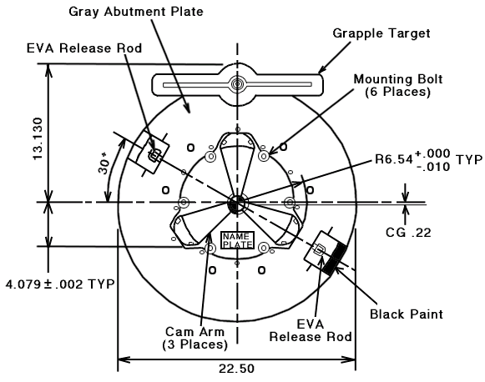 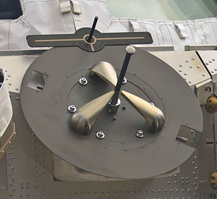

* + Use HST or rebooster ADCS to orient combined spacecraft for reboost
  + Reboost thrust must result in solar array boom deflection of no more than 50cm
  + Undock from HST and destructively de-orbit into atmosphere
  + Send and receive state-vector, attitude, and system health telemetry to/from HST
  + Send and receive state-vector, attitude, and system health telemetry to/from NASA Mission Control Center (MCC), either directly, or indirectly via HST and or TDRS satellites
  + Be able to recover from one Single Event Upset per hour in the onboard Command and Control Computer
  + No requirement on duration of mission
  + Power and thermal requirements not specified – to be determined by design to meet mission objectives
  + Main body of spacecraft bus must include MMOD shielding (impact spec TBD)
  + ADCS must be able to recover from/override both jet-fail-on, and jet-fail cases during proximity operations without collision of mission failure
  + Loss of communications between rebooster and HST or MCC must not result in collision